

EXP NO 1: CREATE A SIMPLECLOUD SOFTWARE APPLICATION AND PROVIDEIT AS A SERVICE USING ANY CLOUD SERVICE PROVIDER TODEMONSTRATE
SOFTWARE AS A SERVICE (SAAS).
DATE:
AIM:
To create a simple cloud software application and provide it as a service using
any cloud service provider todemonstrate software as a service (saas).
PROCEDURE:
STEP1: GOTO ZOHO.COM
STEP 2: LOGIN TO THE ZOHO.COM
STEP 3: SELECT ONE APPLICATION
STEP 4: ENTER APPLICATION NAME
STEP 5: CREATED NEW APPLICATION
STEP 6: SELECT ONE FORM
STEP 7: THE SOFTWARE HASE BEEN CREATED.

IMPLEMENTATION:
1.GO TO ZOHO.COM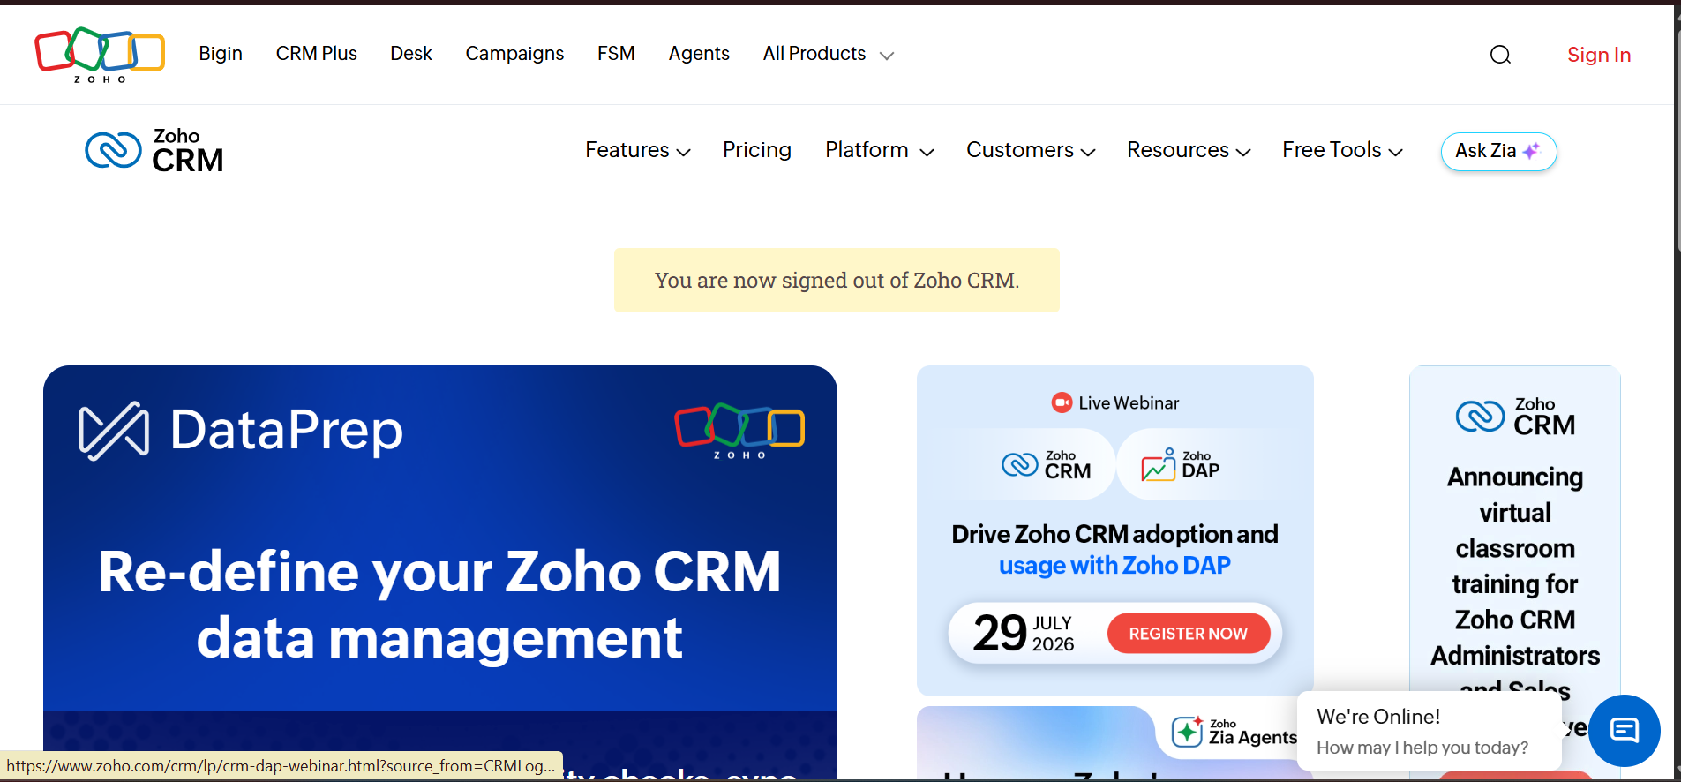

2.LOGIN TO THE ZOHO.COM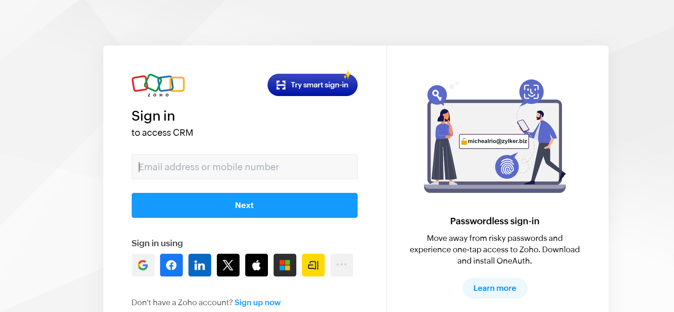

STEP 3: SELECT ONE APPLICATION
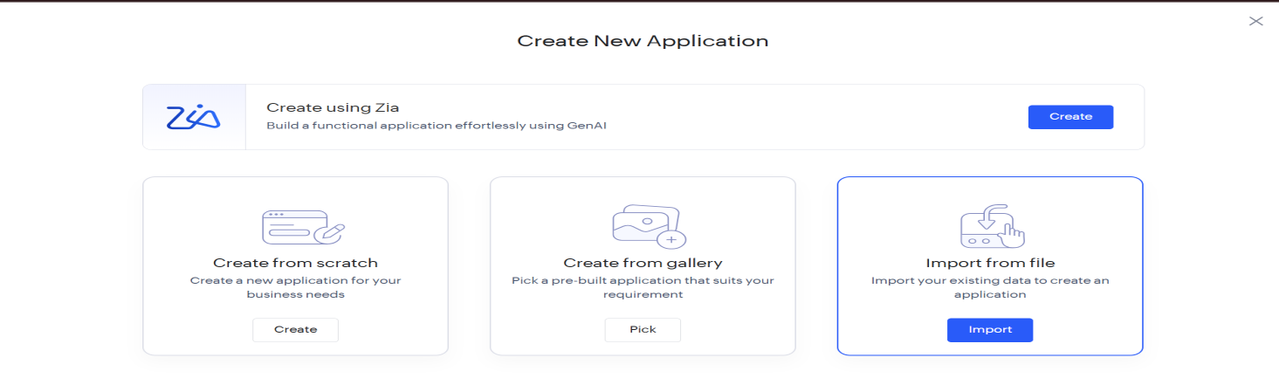
STEP 4: ENTER APPLICATION NAME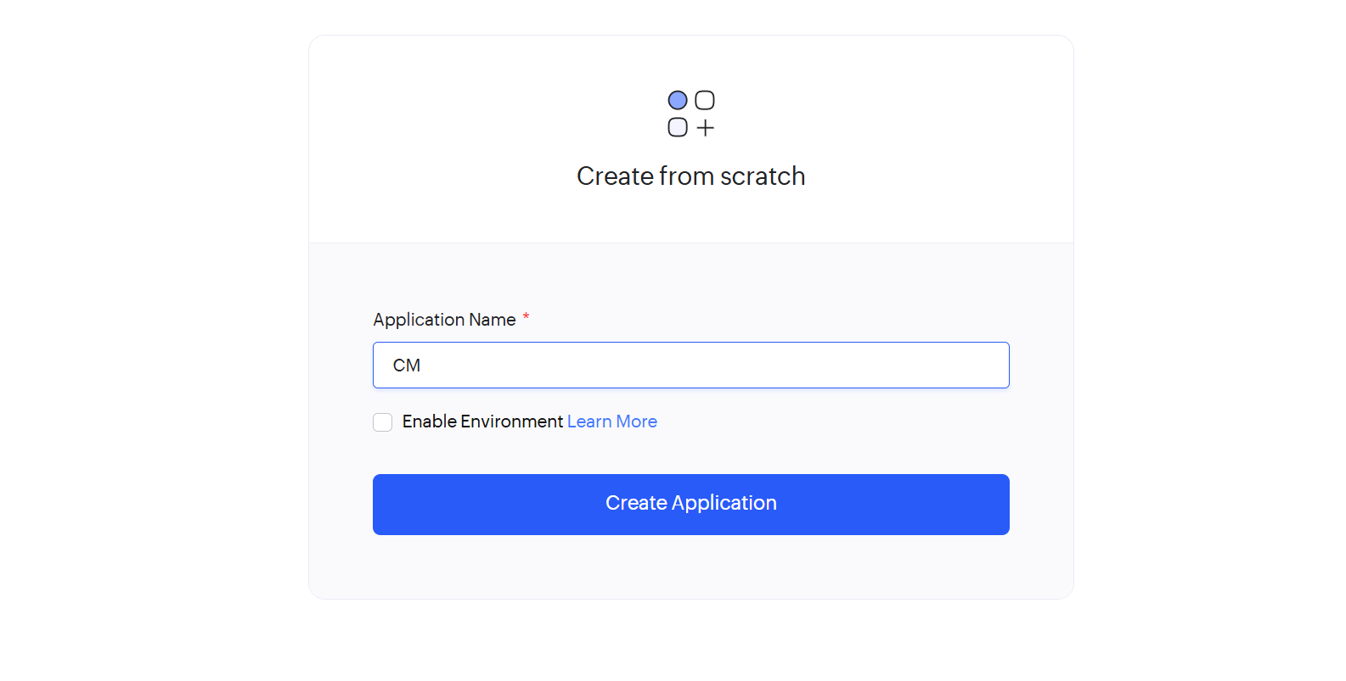
STEP 5: CREATED NEW APPLICATION
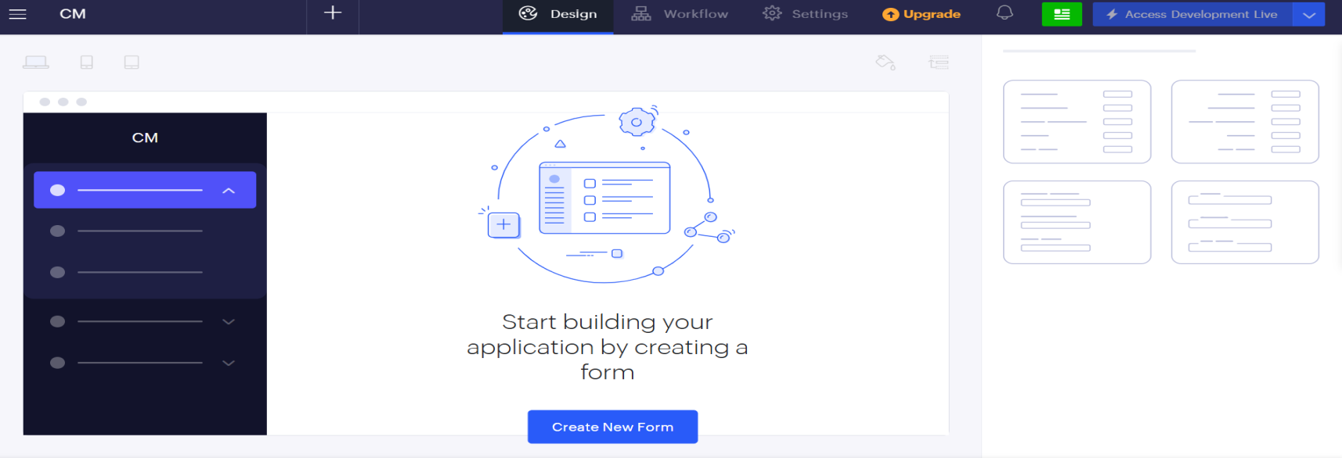

STEP 6: SELECT ONE FORM
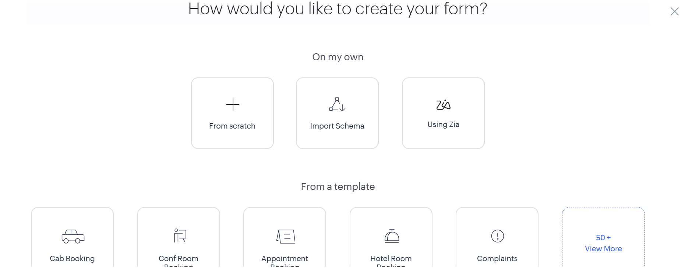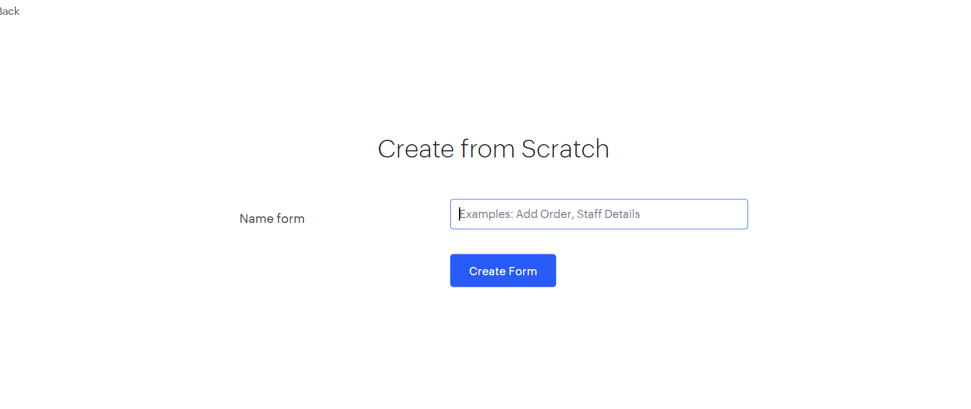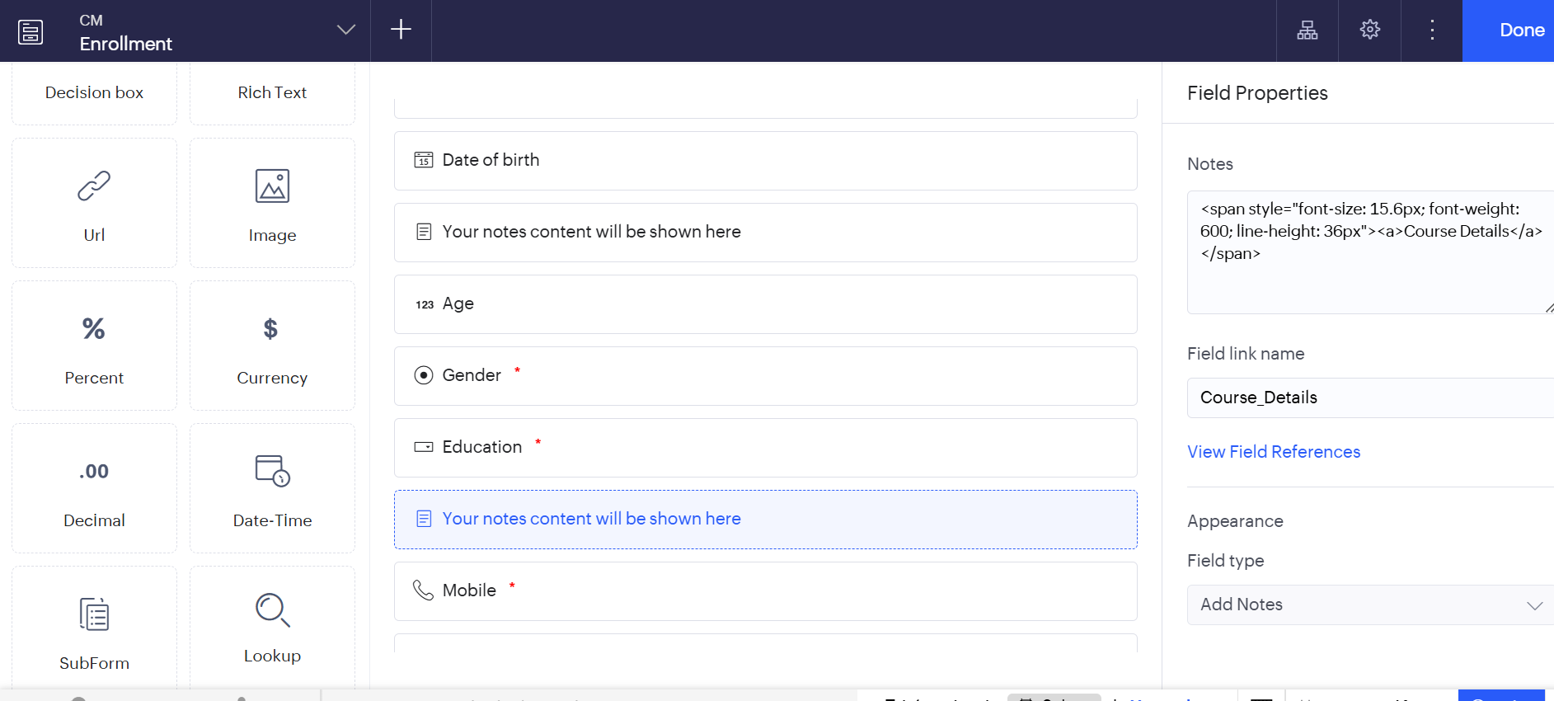 STEP 7: THE SOFTWARE HASE BEEN CREATED